Day-1 Introduction to Network protocols Theory

Q1. Use Wireshark to capture network traffic while you load www.spotify.com in your browser, then identify and note down at least two DNS packets and two HTTP or HTTPS packets in the capture.
Ans:
Steps Performed:
- Opened Wireshark.
- Selected the active Wi-Fi interface.
- Started packet capture.
- Opened www.spotify.com in the web browser.
- Stopped the capture after the website loaded.
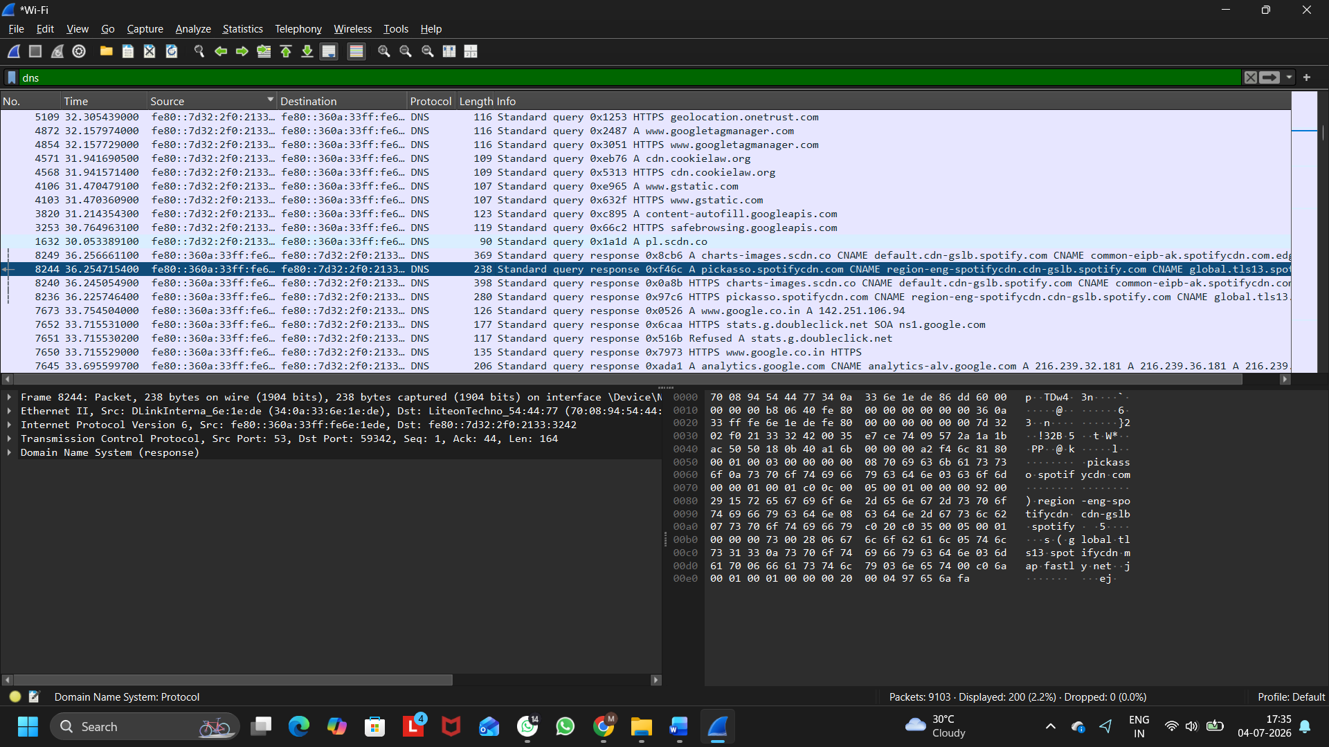
- Used the filters dns and tls to identify the required packets.

Figure 1: Wireshark Capture Showing DNS Packets

DNS Packets Identified:
Packet | Description
DNS Packet1 | Standard Query for picasso.spotifycdn.com
DNS packet 2 | Standard Response containing the IP address for picasso.spotifycdn.com

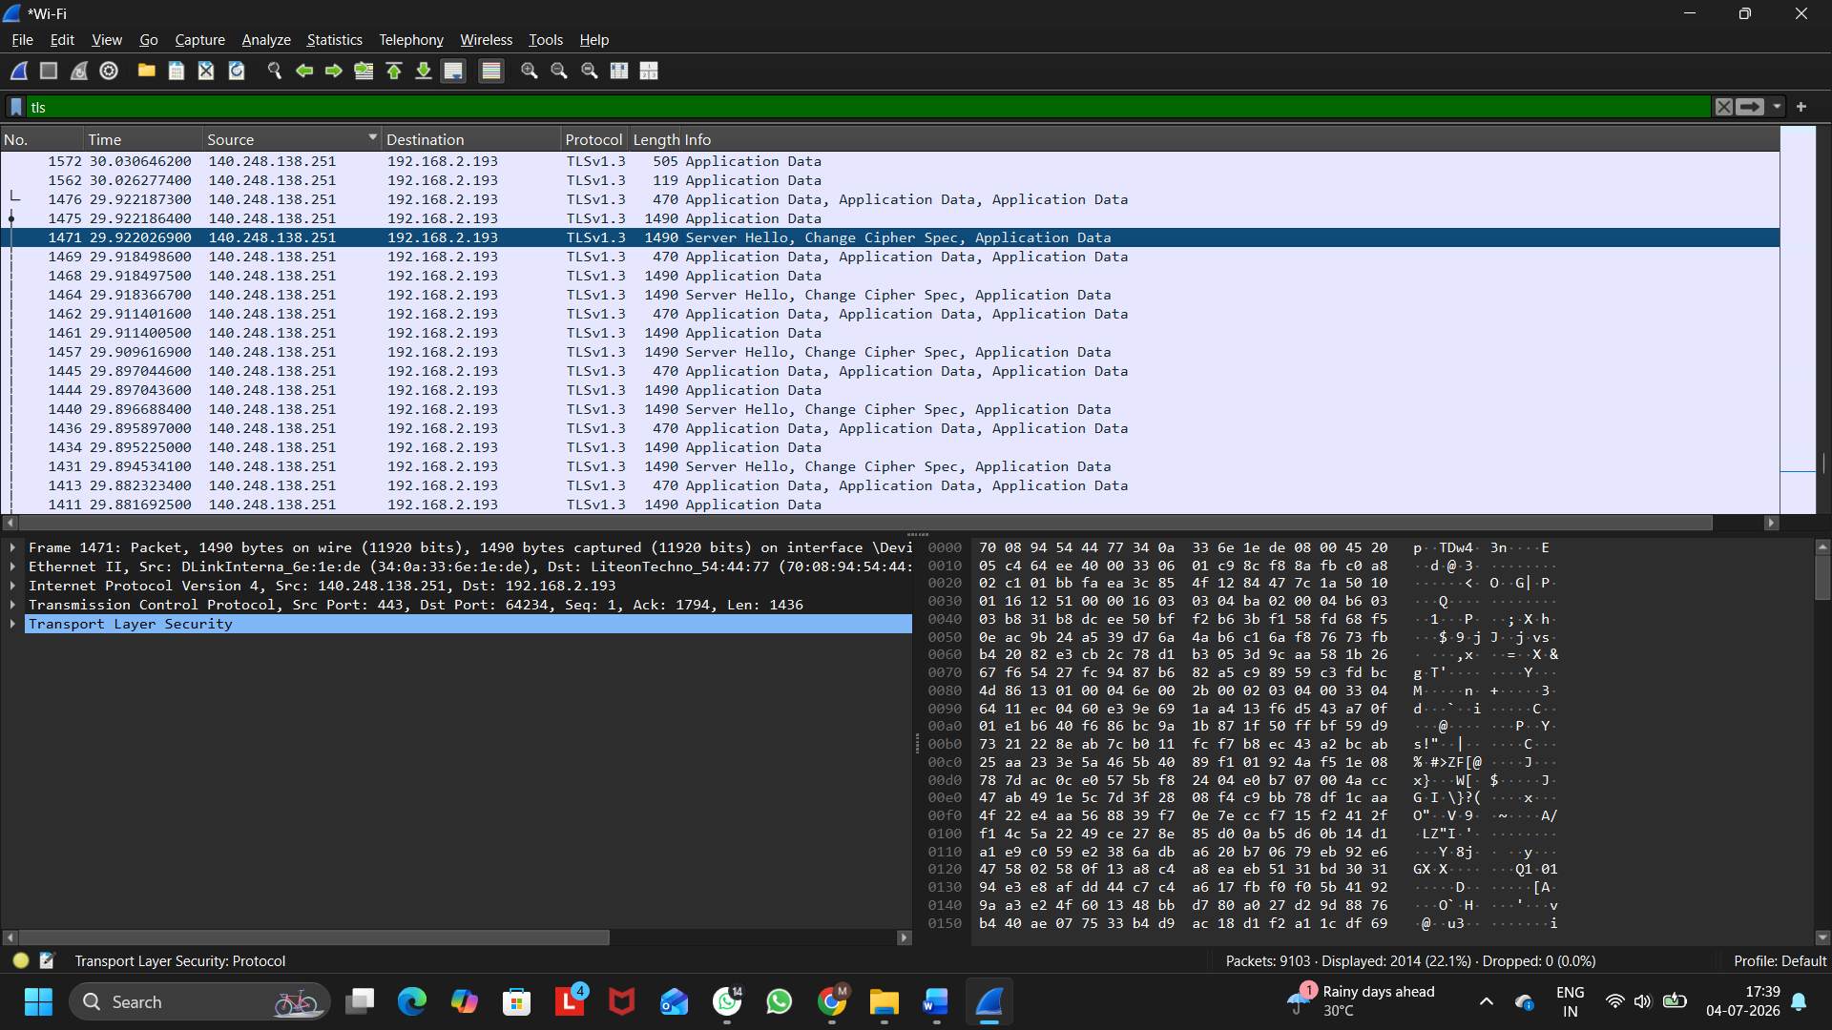
Figure 2: Wireshark Capture Showing HTTPS (TLS) Packets

HTTPS (TLS) Packets Identified:
Packet | Description
HTTPS Packet 1 | TLSv1.3 Server Hello, Change Cipher Spec
HTTPS Packet 2 | TLSv1.3 Application Data

Q2. Simulate a DNS lookup for www.flipkart.com using the nslookup command in your terminal and write down the IP address returned along with a brief explanation of what this result means.
Ans:
IP Address Returned: 103.243.32.90

Brief Explanation:
The nslookup command queries the Domain Name System (DNS) to find the IP address associated with a domain name. In this case, www.flipkart.com was resolved to the IP address 103.243.32.90, which means the DNS server translated the website name into an IP address so that the computer can locate and connect to the Flipkart web server over the Internet.
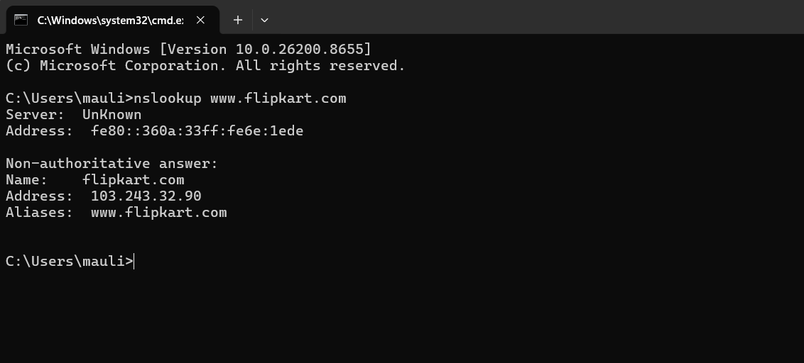
Figure 1: nslookup Result for www.flipkart.com

Q3.Explain the difference between HTTP and HTTPS by listing 3 key differences, and give a real-world example of an app or website you use that relies on HTTPS for secure communication.
Ans:
Difference Between HTTP and HTTPS:
HTTP | HTTPS
HTTP does not encrypt data transmitted between the browser and the server. | HTTPS encrypts data using SSL/TLS, making communication secure.
Data can be intercepted or modified by attackers. | Data is protected from interception and tampering.
HTTP websites display http:// and may be marked as Not Secure. | HTTPS websites display https:// and show a secure connection indicator.

Real-World Example:
Website: Amazon (https://www.amazon.in)
Amazon uses HTTPS to securely transmit login credentials, personal information, payment details, and online transactions. HTTPS encrypts this data and protects users from unauthorized access and cyber attacks.
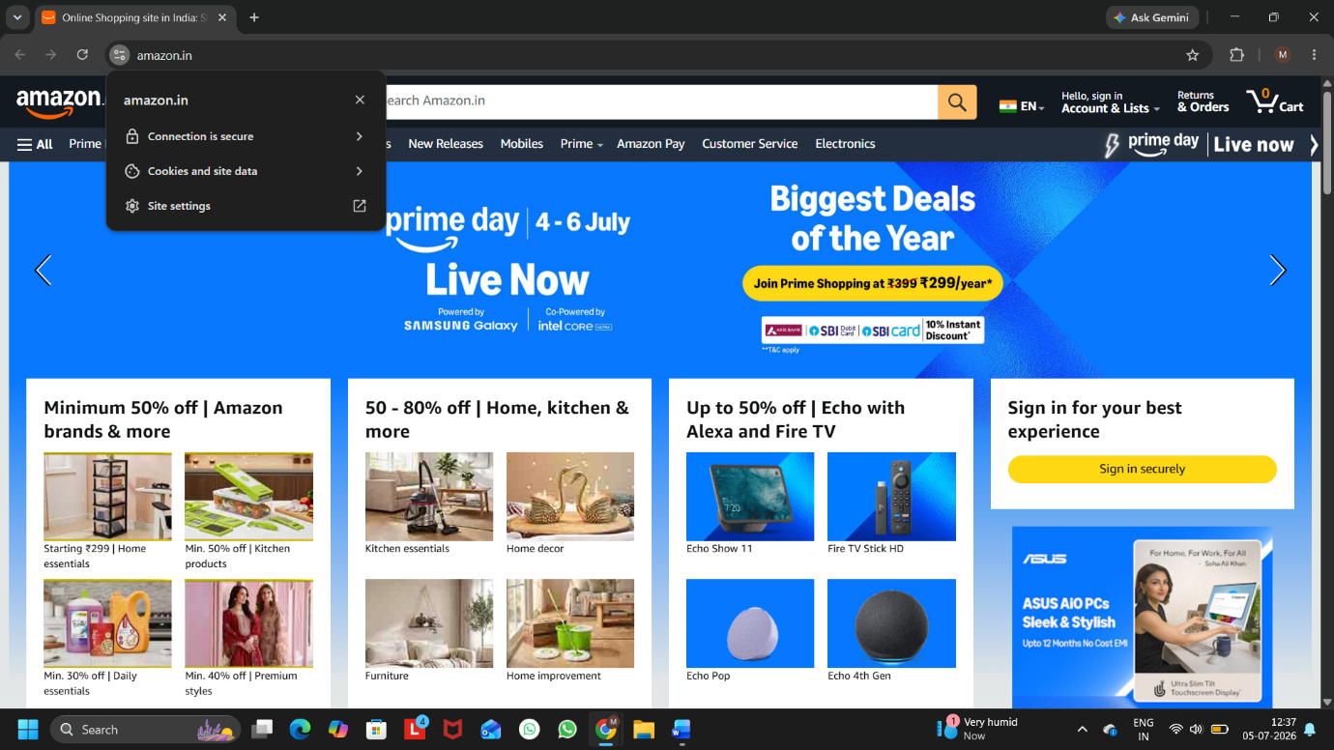
Figure 1: Amazon Website Using HTTPS Secure Connection

Q4.Open Wireshark and filter for DNS protocol traffic. Try searching for a new website (one you haven't visited recently) in your browser and describe the sequence of DNS queries and responses you observe.<br><br><em><strong>Hint:</strong> Look for packets with 'Standard query' and 'Standard query response' in the Info column.</em>
Ans:
DNS Query and Response Observation:
the DNS communication process. After applying the DNS filter in Wireshark, I searched for a website and observed

Observed Sequence:
- A Standard DNS Query was sent from my computer to the DNS server requesting the IP address of telemetry.canva.com.
- The DNS server processed the request and returned a Standard DNS Query Response.
- The response contained a CNAME (Canonical Name) record along with the corresponding IP address of the requested domain.
- After receiving the DNS response, the browser was able to connect to the website using the returned IP address.
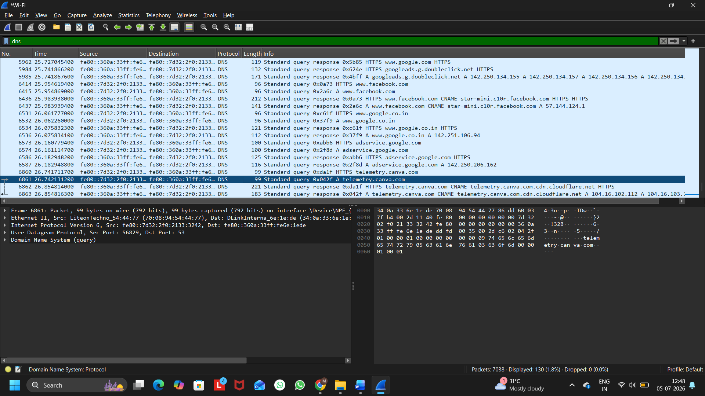
Figure 1: Wireshark Capture Showing DNS Standard Query and Standard Query Response

Q5. Pick any one protocol from DNS, DHCP, FTP, or SNMP (other than HTTP/HTTPS) and write a short scenario describing how it would be used in a real-world app or service you use (for example, how DHCP helps your phone connect to WiFi when you open Instagram at a cafe).
Ans:

Protocol Chosen: DNS (Domain Name System)

Scenario:
I use Spotify every day to listen to music. When I open the Spotify app, my device first sends a DNS request to find the IP address of Spotify's server. The DNS server replies with the correct IP address, and then my device connects to the Spotify server. This allows the app to load songs, playlists, and other content successfully.

Conclusion:
DNS works like the internet's phonebook. It converts a website or app name (such as spotify.com) into an IP address so that the device can communicate with the correct server.

